**Design Principle for Pizza Ordering Application**

The design principle for the Pizza Ordering web application can be depicted using the figure shown below.

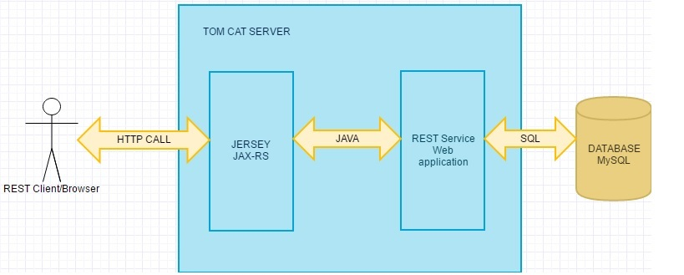

Some important points to be noted are as follows:-

1. JAX-RS framework provides support in creating the Web Services.
2. The client can make a REST call to the web service using various HTTP methods like GET, POST, PUT, DELETE, etc.
3. The Web application is deployed on the Tom Cat server.
4. The business logic is written in Java and handles the client request.
5. The web application also connects to the database to perform data operation tasks.